9.G 7.teden
POMEMBNO!
V tekočem tednu boste v easistentu (Komunikacija) dobili navodila za govorni nastop – obnova prebrane knjige in besedišče, ki ga bom ocenila. Spremljajte pošto v Asistentu in uspešno opravite nalogo.

NOTTING HILL CARNIVAL
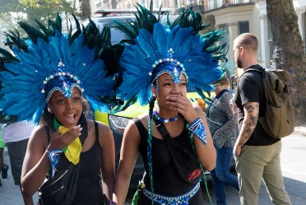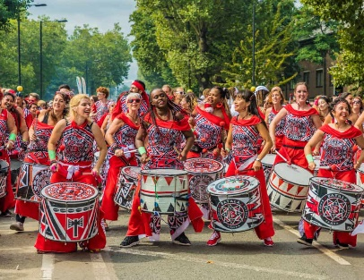

1. Na spodnji spletni povezavi si preberite članek o karnevalu. Nato sestavite pogovor med novinarjem in organizatorjem karnevala. Vprašanja so že oblikovana ( lahko dodaste še svoje), odgovarjajte pa z več kot eno povedjo.
https://www.thelondonnottinghillcarnival.com/
INTERVIEW:
- What is the reason for Notting Hill Carnival?
- What is Notting Hill Carnival celebrating?
- What is Notting Hill Carnival famous for?
- What day and date is Notting Hill Carnival 2020?
- How many days is the Notting Hill Carnival?
- How much are Notting Hill Carnival tickets?
- How should I dress for Notting Hill Carnival?
- When was the first Notting Hill Carnival held?
- How many volunteers attend Notting Hill Carnival?
- Can you give me any safety tips?

Lep pozdrav.

